**Operating Systems Lab**

**Fall 2024**

**Lab Task 11:**



**Lab Instructor:**

**Ma’am Kausar**

**Submitted by:**

**Javeria Inam**

**39977**

**Lab Task 11**

**Question 01**

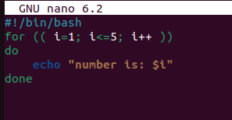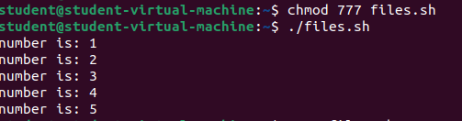

**Question 02**

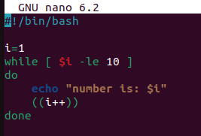

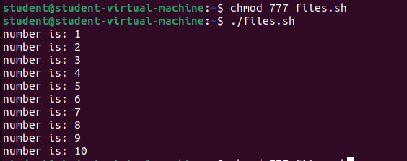

**Question 03**

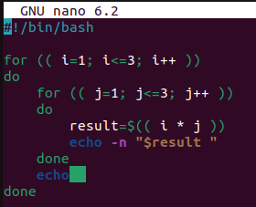

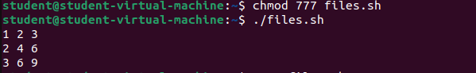

**Question 04**

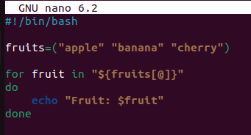

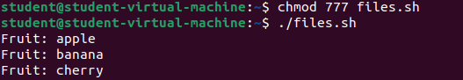

**Question 05**

